**СБОРКИ, БИБЛИОТЕКИ, АТРИБУТЫ, ДИРЕКТИВЫ**

Задание 1.

Листинг программы:

namespace HouseholdAppliances;  
  
public class WashingMachine: Technique  
{  
 public int MaxLoad { get; set; }  
 public int MaxSpinSpeed { get; set; }  
 public int MaxTemperature { get; set; }  
  
 public WashingMachine(string name, string manufacturer, double power, double weight, double price, int maxLoad, int maxSpinSpeed, int maxTemperature)  
 {  
 Name = name;  
 Manufacturer = manufacturer;  
 Power = power;  
 Weight = weight;  
 Price = price;  
 MaxLoad = maxLoad;  
 MaxSpinSpeed = maxSpinSpeed;  
 MaxTemperature = maxTemperature;  
 }  
}

namespace HouseholdAppliances;  
  
public class VacuumCleaner: Technique  
{  
 public int DustContainerVolume { get; set; }  
 public int NoiseLevel { get; set; }  
   
 public VacuumCleaner(string name, string manufacturer, double weight, double price, int power, int dustContainerVolume, int noiseLevel)  
 {  
 Name = name;  
 Manufacturer = manufacturer;  
 Power = power;  
 Weight = weight;  
 Price = price;  
 Power = power;  
 DustContainerVolume = dustContainerVolume;  
 NoiseLevel = noiseLevel;  
 }  
}

namespace HouseholdAppliances;  
  
public class Oven: Technique  
{  
 public int Temperature { get; set; }  
 public int Speed { get; set; }  
 public int Volume { get; set; }  
  
 public Oven(string name, string manufacturer, double power, double weight, double price, int temperature, int speed, int volume)  
 {  
 Name = name;  
 Manufacturer = manufacturer;  
 Power = power;  
 Weight = weight;  
 Price = price;  
 Temperature = temperature;  
 Speed = speed;  
 Volume = volume;  
 }  
}

Входные и выходные данные:

|  |  |
| --- | --- |
| Входные | Выходные |
| "WashingMachine", "LG", 2000, 100, 500, 5, 1000, 90 | "WashingMachine", "LG", 2000, 100, 500, 5, 1000, 90 |

Анализ результатов:

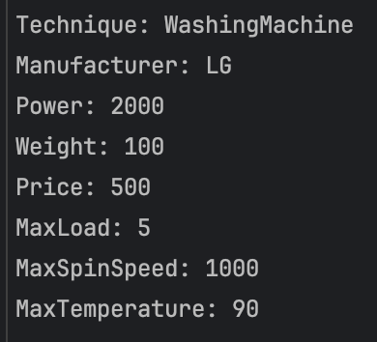

Рисунок 1 – Результат работы программы